Practical No-03
Aim: Estimation of Project matrix and design Gnatt chart
Problem Statement: AI Stock Analyzer

A Project Estimation Matrix is a structured format used to estimate time, effort, resources, and cost for each module/task of a project. It helps in planning and tracking.

Task ID | Task Name | Assigned To | Estimated Hours | Actual Hours | Start Date | End Date | Status
T1 | Requirement Gathering | Atharva | 10 hrs | 14 hrs | 20-Aug-25 | 23-Aug-25 | Completed
T2 | UI Design | Designer | 15 hrs | 14 hrs | 24-Aug-25 | 27-Aug-25 | In Progress
T3 | Backend Development | Developer | 25 hrs | - | 28-Aug-25 | 5-Sept-25 | Pending

Example of a Project Estimation Matrix
Component | Description | Estimation Technique | Estimation (Example)
Effort | Number of person-hours required | Function Point Analysis | 1,000 person-hours
Time (Duration) | Calendar time for project completion | PERT/CPM | 3 months
Cost | Estimated budget for project | Bottom-Up Estimation | $50,000
Size | Size of the software | Function Points | 300 function points
Resources | Number of developers, testers, etc. required | Expert Judgment | 4 developers, 2 testers
Risk | Contingency for identified risks | Risk Analysis (Qualitative) | 10% buffer on time/cost

Example: Library Management System (Mini Project)
Task ID | Module | Est. Hours | Resources | Complexity | Remarks
1 | Login/Authentication | 6 hrs | Developer A | Low | Simple form
2 | Book Search | 10 hrs | Developer B | Medium | Uses database
3 | Book Issue/Return | 15 hrs | Developer A, B | High | With logic
4 | Admin Dashboard | 8 hrs | Developer A | Medium | Stats, graphs

Task ID | Module | Est. Hours | Resources | Complexity | Hourly Rate (INR) | Estimated Cost (INR)
1 | Login/Authentication | 6 | Developer A | Low | 600 | 3600
2 | Book Search | 10 | Developer B | Medium | 600 | 6000
3 | Book Issue/Return | 15 | Developer A, B | High | 600 | 9000
4 | Admin Dashboard | 8 | Developer A | Medium | 600 | 4800
 |  |  |  | Total Cost

2. Gantt Chart Design
Steps to Design a Gantt Chart
A Gantt chart is a bar chart that visually represents the schedule of a project, showing tasks over time. Here's how to design one step-by-step:

Step-by-Step Process to Design a Gantt Chart
Step 1: Identify Project Tasks
List all the tasks or modules required to complete the project.
- Example:
  - Requirement Gathering
  - UI Design
  - Development
  - Testing
  - Deployment

Step 2: Determine Task Duration
Estimate how long each task will take (in days or hours).
- Example:
  - UI Design – 3 days
  - Development – 6 days

Step 3: Set Start and End Dates
Assign start and end dates for each task based on estimated duration and task dependencies.

Step 4: Identify Task Dependencies
Determine which tasks must be completed before others begin.
- Example:
  - Development starts after UI Design
  - Testing starts after Development

Step 5: Create a Table

Prepare a basic table structure like this:
Task Name | Start Date | Duration | End Date | Progress
UI Design | 01-Aug-25 | 3 days | 03-Aug-25 | 100%
Backend Development | 04-Aug-25 | 6 days | 09-Aug-25 | 60%

Step 6: Plot on a Timeline (Bar Chart)
Use a horizontal bar chart to represent tasks:
- X-axis: Dates or time period
- Y-axis: Task names
- Draw bars from start to end date of each task

Step 7: Add Details
- Color Code: Use different colors for “Completed”, “In Progress”, and “Planned”
- Milestones: Mark important checkpoints
- Progress Indicator: Show how much of each task is completed

Gantt Chart (Library Management System Project)
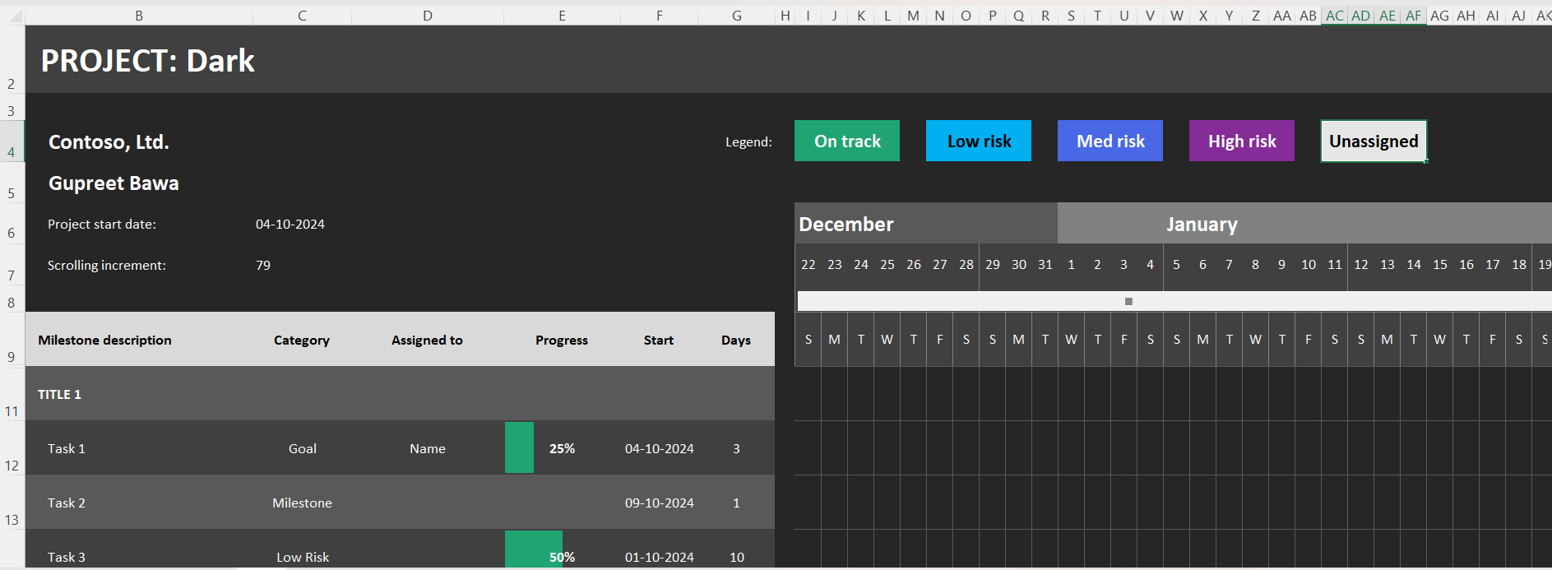

Conclusion:
This practical reinforces the significance of software engineering project management techniques. Understanding and applying cost estimation matrices and Gantt charts are essential skills for ensuring that a project is delivered on time, within budget, and with optimal use of resources. These tools also enhance project visibility, risk management, and stakeholder communication.

